Othello Lab
Inspired by a lab from Chris Nevison
and
Robert Glen Martin

In this lab you will create a playable GridWorld Othello game.
You will be using the GWOthello folder which contains the starting code files for the Othello Lab. First let’s consider the files contained in the starter project. This Eclipse project uses eight java files.
The classes you will be modifying are:
  - OthelloGame – objects of this class represent an Othello game.
  - Piece – objects of this class represent an Othello game piece.
  - OthelloPlayer – an abstract super-class that represents a player.
  - StupidComputerOthelloPlayer – an object of this class represents a stupid computer player. A stupid computer player plays randomly.
  - OthelloRunner – the runner application that creates and starts the game.
The classes that have been fully completed for you are:
  - HumanOthelloPlayer – an object of this class represents a human player.
  - OthelloWorld – a special purpose world that inherits from World
  - PieceDisplay – displays a Piece object. There is no Piece.gif image file.

There is also a Javadocs folder that contains detailed documentation about the final Othello game classes. It would be helpful to refer to this documentation often. Familiarize yourself with the available methods and use them when appropriate!
Figure 1 on the next page also provides information about the main Othello classes.
All classes are covered by the GNU General Public License.
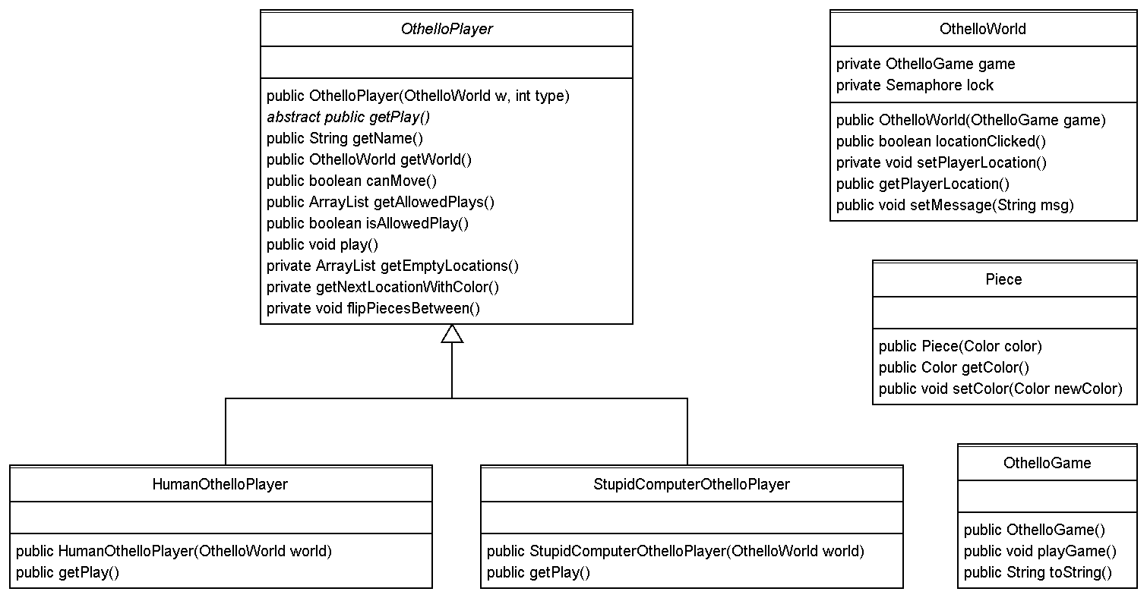
Figure 1 - Main Othello game classes
- Before beginning this lab, you need to understand how to play Othello. Google it and/or check out the following URLs:
  - http://www.centralconnector.com/GAMES/othello.html - the “original” rules.
  - http://www.site-constructor.com/othello/othellorules.html - another “original” rules page.
  - http://david.currie.name/wp-content/othello.pdf - a rules pdf file and a paper that includes ideas about how to make a computer player “smarter”.
- Start out by completing Piece. This is a good choice since it’s used by several of the other classes. Refer to the Javadocs and Figure 1 to add its instance variables, constructor, getter, and setter. Make sure that Piece.java compiles correctly. Also make sure that it passes Checkstyle.
- The project should now have several compile errors, most caused by missing instance variables. Add the instance variables to OthelloGame, and OthelloPlayer.
- Now we are down to one compile error. Since we have not yet written the StupidComputerOthelloPlayer constructor body, it currently has an implied super(); statement. This causes a compile error because OthelloPlayer does not have a zero-parameter constructor. Complete the StupidComputerOthelloPlayer constructor. The name should be "Computer" and the color should be red. Make sure that the project compiles correctly.
- Let’s see what we can do about the Checkstyle errors, there should be several. All but one are caused by incorrect header information. Put your information in the appropriate places. There should now be one remaining Checkstyle error caused by an as yet unused import.
- Complete the StupidComputerOthelloPlayer class by replacing the body of the getPlay method as follows:
  - Get the list of allowed moves using the inherited method made for that purpose.
  - Store this list in an ArrayList named allowedMoves.
  - If there are no allowed moves, then return null.
  - Otherwise return a randomly selected allowed move.
From now on your code should compile and Checkstyle without errors or warnings. Compile and Checkstyle often.
- Tackle OthelloGame next. First complete the constructor:
  - Initialize world with a new Othello world. The game passed to the OthelloWorld constructor should be the current Othello game object.
  - Initialize players with a two element array containing a new human player and a new stupid computer player in that order.
  - Initialize playerIndex to the first index (0).
  - Show the world.
- Complete the OthelloGame class by writing the playGame method. It should loop as long as either player can make a play. For each iteration of the loop it should
  - Get the current player from players.
  - If the current player can make a play, then have that user play.
  - Update playerIndex to “point” to the other player.
  - Set the world’s message using the string returned from this game’s toString. Note that toString has been written for you.
- Complete OthelloRunner’s main method. It should create a new game and then send a message to that game to play the game.
Compile and execute the project. You should see the initial pieces (placed by the OthelloWorld’s constructor) and a message in the message area. You should also see “null plays” printed in the console window about every two seconds. This is caused by OthelloGame playGame’s repeated play calls.
- Now we complete the abstract OthelloPlayer class. It has a constructor, an abstract getMove method, 6 public concrete methods, and 3 private helper methods. The abstract getMove method allows polymorphic execution of the getMove method in HumanOthelloPlayer and StupidComputerOthelloPlayer.
Initialize the 4 instance variables in the constructor. board should be initialized to world’s grid.
Compile and execute the program. You should see the console output alternate between “Human plays” and “Computer plays”.
- We’ll write the three helper methods next, since they are used by the other methods in OthelloPlayer. Start with getEmptyLocations which should return a list of all the empty locations on the board.
To test getEmptyLocations, add the following temporary code to the end of the OthelloPlayer constructor. You should see the list of empty locations printed twice (once each for the construction of the human and the computer players):
System.out.println(getEmptyLocations()); // TEMPORARY
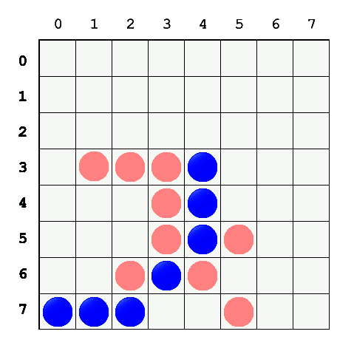
- Next we consider the getNextLocationWithColor method which is key to locating allowed moves. Its purpose is to find the next location with this player's color. It starts with location second and continues in the direction from first to second. See Figure 2 to the left and Table 1 below to help understand how getNextLocationWithColor works. In the examples, assume that the player’s color is blue (the dark color).
Figure 2 - Example Board Position
first | second | Returned Location | Explanation
(3, 0) | (3, 1) | (3, 4) | First blue going East starting with (3, 1)
(2, 2) | (3, 3) | (4, 4) | First blue going South-East starting at (3, 3)
(6, 0) | (7, 0) | (7, 0) | First blue going South starting at (7, 0)
(4, 2) | (5, 3) | null | No blue going South-East ((8, 6) is invalid)
(7, 3) | (6, 4) | null | No blue going North-East ((4, 6) is empty)

Table 1 - Example Table
Replace the temporary getNextLocationWithColor body as follows:

  - Get the direction from first to second. Let’s call it dir.
  - Loop forever. For each iteration of the loop do the following:
    - If second is not a valid board location, then return null.
    - If the board is empty at second, then return null.
    - If the piece at second has the player’s color, then return second.
    - Set second to the adjacent location to second in direction dir.

Replace the temporary code in the OthelloPlayer constructor with the temporary code on the next page. When you execute the project, you should see 5 locations printed. These locations should match those in Table 1.
// BEGIN TEMPORARY CODE
if (color.equals(Color.RED)) return;
world.add(new Location(3, 1), new Piece(Color.RED));
world.add(new Location(3, 2), new Piece(Color.RED));
world.add(new Location(3, 3), new Piece(Color.RED));
world.add(new Location(3, 4), new Piece(Color.BLUE));
world.add(new Location(4, 3), new Piece(Color.RED));
world.add(new Location(4, 4), new Piece(Color.BLUE));
world.add(new Location(5, 3), new Piece(Color.RED));
world.add(new Location(5, 4), new Piece(Color.BLUE));
world.add(new Location(5, 5), new Piece(Color.RED));
world.add(new Location(6, 2), new Piece(Color.RED));
world.add(new Location(6, 3), new Piece(Color.BLUE));
world.add(new Location(6, 4), new Piece(Color.RED));
world.add(new Location(7, 0), new Piece(Color.BLUE));
world.add(new Location(7, 1), new Piece(Color.BLUE));
world.add(new Location(7, 2), new Piece(Color.BLUE));
world.add(new Location(7, 5), new Piece(Color.RED));
System.out.println(getNextLocationWithColor(
new Location(3, 0), new Location(3, 1)));
System.out.println(getNextLocationWithColor(
new Location(2, 2), new Location(3, 3)));
System.out.println(getNextLocationWithColor(
new Location(6, 0), new Location(7, 0)));
System.out.println(getNextLocationWithColor(
new Location(4, 2), new Location(5, 3)));
System.out.println(getNextLocationWithColor(
new Location(7, 3), new Location(6, 4)));
// END TEMPORARY CODE
- Complete flipColorOfPieces which changes the color of a line of pieces to the current player’s color. The first piece to be changed is in location start. The last piece to be changed is in the location immediately before end.
Add the following additional temporary code to the end of the OthelloPlayer constructor temporary code (just before // END TEMPORARY CODE). Now when you execute the project, the pieces at locations (3, 1), (3, 2), (3, 3), and (5, 5) should now be blue.
flipColorOfPieces(new Location(5, 5), new Location(4, 4));
flipColorOfPieces(new Location(3, 1), new Location(3, 4));
- Next let’s write the public methods. Write the getName and getWorld accessor methods.
- Write the canPlay method. This can be one statement long. If it takes more than two statements, you didn’t do it correctly! If you try to execute the project now you will receive a NullPointerException. We’ll fix that in 16.
- Write the getAllowedPlays method which returns an ArrayList of Locations that the current player is allowed to play. Search for allowed locations as follows:
  - Loop through the empty locations. We’ll call each such location empty. For each empty
    - Loop through all of empty’s occupied adjacent locations. We’ll call each such location adjacent. For each adjacent:
      - Get the next location with color from empty to adjacent
      - If that next location is not null and does not equal adjacent, then empty is an allowed location.
Replace all the temporary code at the end of the OthelloPlayer constructor with the following temporary code. Executing the project now should print the four legal human (blue) moves followed by the four legal computer (red) moves. Check them!
System.out.println(getAllowedPlays()); // TEMPORARY
- Write isAllowedPlay. It should check to see if loc is one of the allowed locations to play.
Replace the temporary code at the end of the OthelloPlayer constructor with the following temporary code. Executing the project now should print true and then false because (2, 3) is an allowed play for the human (blue), but not for the computer (red).
System.out.println( // TEMPORARY
isAllowedPlay(new Location(2, 3))); // TEMPORARY
You are now finished with the temporary code. Delete it.
- Write play as follows:
  - Get the next location to play. Let’s call that location playLoc.
  - Place a new piece at playLoc.
  - Loop through each occupied adjacent location to playLoc. Let’s call each of those locations adjacent. For each adjacent:
    - Get the next location with color using playLoc as first and adjacent as second. Let’s call that location next.
    - If next is not null and not equal to adjacent, then flip the color of the pieces from adjacent (inclusive) to next (exclusive).
Test your code by playing the game. If you have problems you may want to add print statements at revealing places in your code to understand what’s happening.
- Before you turn in your program, make sure to remove all debugging print statements. Also make sure your code compiles without errors or warnings and that it passes Checkstyle
Extra Credit
Design, write, and use a SmartComputerOthelloPlayer class that plays more intelligently. You may want to refer to the URL list on the second page of this assignment.

